**Data Base Assignment B7, B8, B9**

**CS 5332**

**Fall - 2016**

**INSTRUCTOR: DR.C.J. HWANG**

**Submitted to: DR.C.J. HWANG**

**Submitted by: Anusha Vattam**

**B7: Formation of Preliminary Database**

**Project Name/ Data Base Name: Travel Agencies**

**It consists of tables:**

Travel_Agency

Staff_Agency

Customers

Calendar

Booking Outcomes

BookingStatus

BookingServiceLevel

Services

Services Bookings

payments

Bookings

Creation of Tables:

**Table creation:**

CREATE TABLE Travel_Agency (travel_ID VARCHAR(50), Name VARCHAR (50) ,City VARCHAR (50),State VARCHAR (50),Zip INTEGER,CONSTRAINT PK_Travel PRIMARY KEY (travel_ID));

**Data Insertion:**

INSERT INTO Travel_Agency (travel_ID , Name, City ,State ,Zip )VALUES ('TA45', 'Money Makers', 'San Jose', 'CA', '198076');

INSERT INTO Travel_Agency (travel_ID , Name ,City ,State ,Zip)VALUES ('TA23', 'Makemytrip', 'San Marcos', 'SM', '165890');

INSERT INTO Travel_Agency (travel_ID , Name , City ,State ,Zip)VALUES ('TA12', 'Easygo', 'Dallas', 'TX', '177025');

INSERT INTO Travel_Agency (travel_ID , Name ,City ,State ,Zip)VALUES ('TA10', 'Anu Travels', 'Austin', 'TX', '178654');

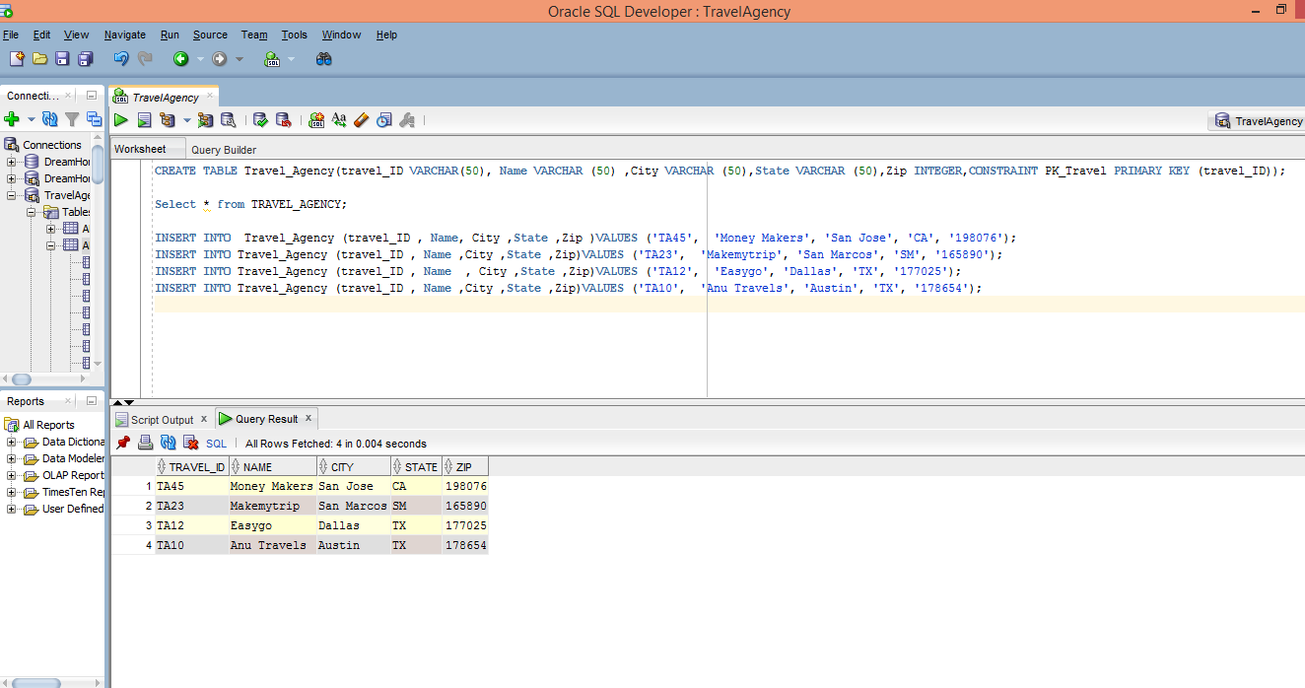

Staff_Agency :

CREATE TABLE Staff_Agency(StaffAID VARCHAR(50), FName VARCHAR (50), LName VARCHAR(50), Email VARCHAR (50), PhoneNo VARCHAR (50), EnrollDate VARCHAR(20), CONSTRAINT PK_Staff PRIMARY KEY (StaffAID));

INSERT INTO Staff_Agency(StaffAID , FName , LName, Email , PhoneNo , EnrollDate)VALUES ('ST76', 'Sowmya', 'Dose', 'xyz@gmail.com', '667-098-4567', '05-12-2003');

INSERT INTO Staff_Agency(StaffAID , FName , LName, Email , PhoneNo , EnrollDate)VALUES ('ST80', 'sanjay', 'mishra', 'goto@gmail.com', '667-098-4567', '05-10-2013');

INSERT INTO Staff_Agency(StaffAID , FName , LName, Email , PhoneNo , EnrollDate)VALUES ('ST90', 'Anusha', 'jones', 'homedays@gmail.com', '667-098-4567', '08-1-2053');

INSERT INTO Staff_Agency(StaffAID , FName , LName, Email , PhoneNo , EnrollDate)VALUES ('ST92', 'lekha', 'puppala', 'xyz123@gmail.com', '667-098-4567', '09-2-2063');

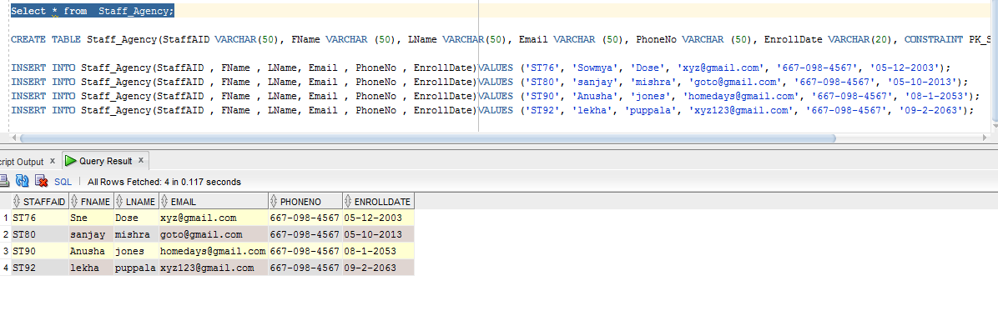

Customers :

CREATE TABLE Customers(CustID VARCHAR(50), FName VARCHAR (50) , LName VARCHAR (50),City VARCHAR (50),State VARCHAR (50),Zip INTEGER,CONSTRAINT PK_cust PRIMARY KEY (CustID));

INSERT INTO Customers (CustID , FName , LName ,City ,State ,Zip )VALUES ('CS45', 'John', 'Peters', 'San Jose', 'CA', '198076');

INSERT INTO Customers (CustID , FName , LName ,City ,State ,Zip)VALUES ('CS23', 'Tom', 'Edwards', 'New York', 'NY', '615890');

INSERT INTO Customers (CustID , FName , LName ,City ,State ,Zip)VALUES ('CS12', 'Ella', 'Jiang', 'Houston', 'TX', '771025');

INSERT INTO Customers (CustID , FName , LName ,City ,State ,Zip)VALUES ('CS10', 'Ann', 'Watsaon', 'Austin', 'TX', '718654');

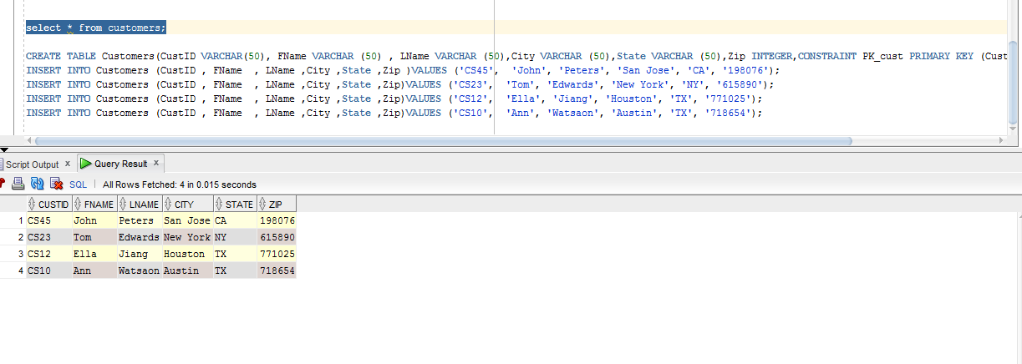

Calendar:

CREATE TABLE Calendar(CalID VARCHAR(50),Datecal VARCHAR (50),Daycal VARCHAR (50),comments VARCHAR(50),CONSTRAINT PK_cal PRIMARY KEY (CalID));

INSERT INTO Calendar(CalID,Datecal,Daycal,comments)VALUES ('CA11','05-12-2003','Monday','need new members');

INSERT INTO Calendar(CalID,Datecal,Daycal,comments)VALUES ('CA10','05-10-2013','Tuesday','comments');

INSERT INTO Calendar(CalID,Datecal,Daycal,comments)VALUES ('CA8','08-1-2053','Tuesday','No bookings');

INSERT INTO Calendar(CalID,Datecal,Daycal,comments)VALUES ('CA9','09-2-2063','Friday','No comments');

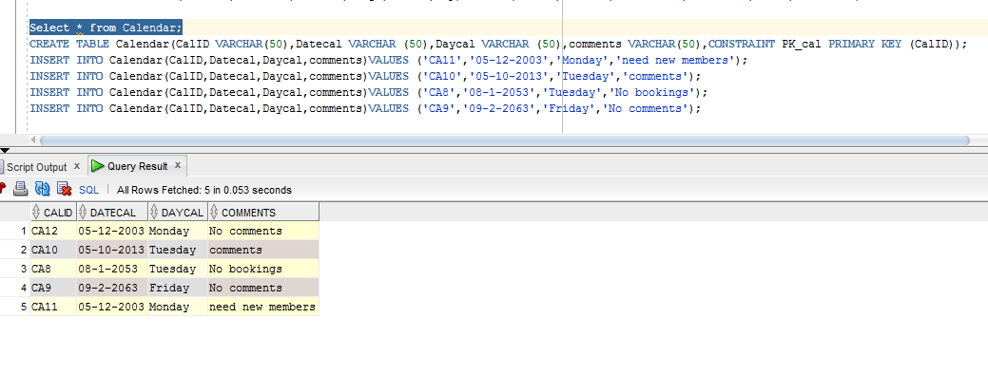

Booking Outcomes:

CREATE TABLE BookingOutcomes(OutComeCode VARCHAR(50),OutcomeDesc VARCHAR (50),CONSTRAINT PK_Out PRIMARY KEY (OutComeCode));

INSERT INTO BookingOutcomes(OutComeCode,OutcomeDesc )VALUES ('O2','Cancelled');

INSERT INTO BookingOutcomes(OutComeCode,OutcomeDesc )VALUES ('O3','OK');

INSERT INTO BookingOutcomes(OutComeCode,OutcomeDesc )VALUES ('O4','Processing');

INSERT INTO BookingOutcomes(OutComeCode,OutcomeDesc )VALUES ('O5','Cancelled');

select * from BookingOutcomes;

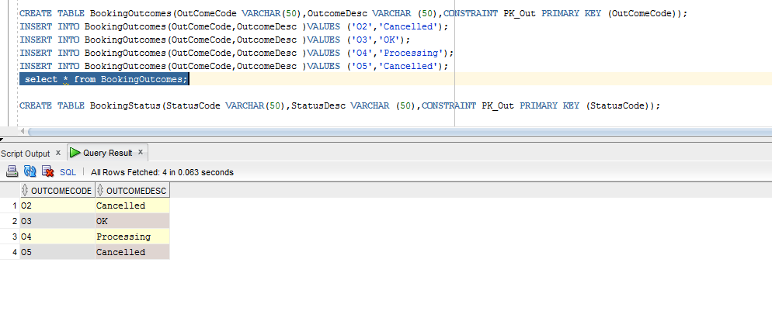

BookingStatus:

CREATE TABLE BookingStatus(StatusCode VARCHAR(50),StatusDesc VARCHAR (50),CONSTRAINT PK_Status PRIMARY KEY (StatusCode));

INSERT INTO BookingStatus(StatusCode,StatusDesc )VALUES ('S4','Provisional');

INSERT INTO BookingStatus(StatusCode,StatusDesc )VALUES ('S3','Processing');

INSERT INTO BookingStatus(StatusCode,StatusDesc )VALUES ('S5','waitingList');

INSERT INTO BookingStatus(StatusCode,StatusDesc )VALUES ('S2','Cancelled');

select * from BookingStatus;

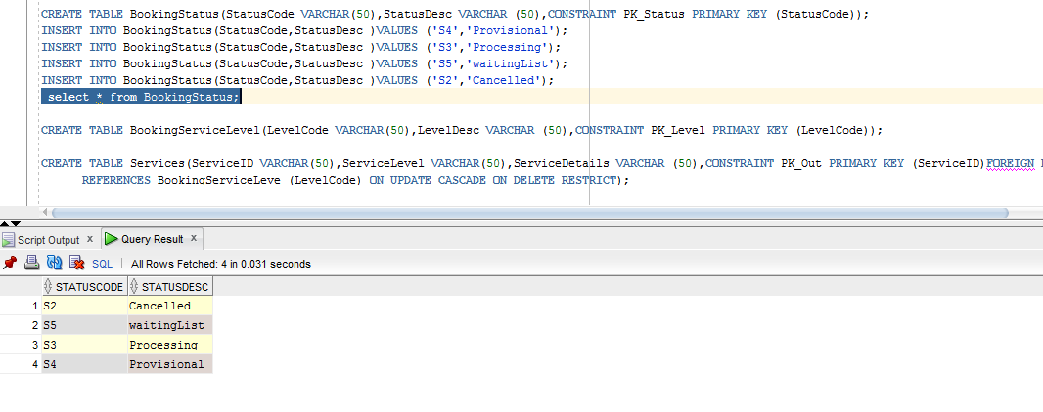

BookingServiceLevel:

CREATE TABLE BookingServiceLevel(LevelCode VARCHAR(50),LevelDesc VARCHAR (50),CONSTRAINT PK_Level PRIMARY KEY (LevelCode));

INSERT INTO BookingServiceLevel(LevelCode,LevelDesc )VALUES ('L4','Compact Car 5');

INSERT INTO BookingServiceLevel(LevelCode,LevelDesc )VALUES ('L3','Business class');

INSERT INTO BookingServiceLevel(LevelCode,LevelDesc )VALUES ('L2','Flight level');

INSERT INTO BookingServiceLevel(LevelCode,LevelDesc )VALUES ('L1','star hotel');

INSERT INTO BookingServiceLevel(LevelCode,LevelDesc )VALUES ('L5','Motels');

select * from BookingServiceLevel;

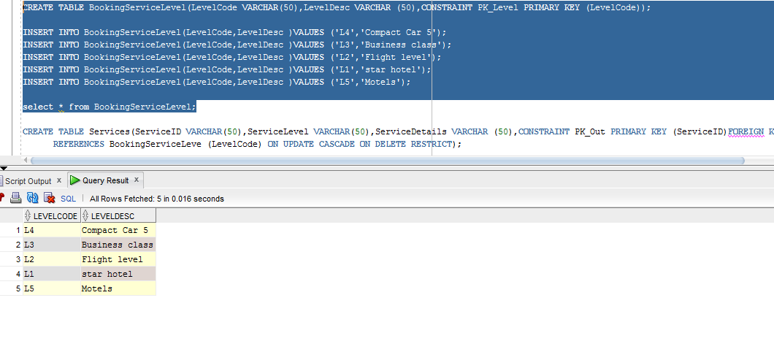

Services

CREATE TABLE Services(ServiceID VARCHAR(50),LevelCode VARCHAR(50),ServiceDetails VARCHAR (50),CONSTRAINT PK_Service PRIMARY KEY (ServiceID) ,CONSTRAINT fk_LevelCode FOREIGN KEY (LevelCode) REFERENCES BookingServiceLevel (LevelCode));

INSERT INTO Services(ServiceID, LevelCode, ServiceDetails)VALUES ('SL01','L4','Airways');

INSERT INTO Services(ServiceID, LevelCode, ServiceDetails)VALUES ('SL04','L2','Cars');

INSERT INTO Services(ServiceID, LevelCode, ServiceDetails)VALUES ('SL03','L1','Star Hotels');

INSERT INTO Services(ServiceID, LevelCode, ServiceDetails)VALUES ('SL05','L5','Motels');

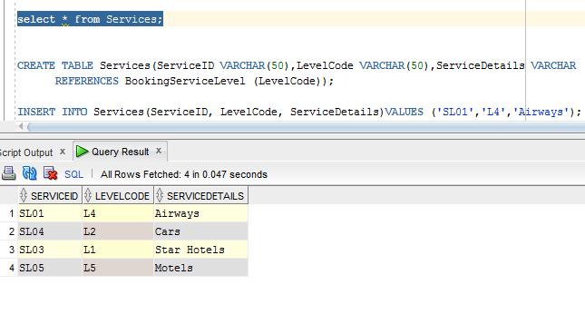

Services Bookings

CREATE TABLE ServiceBookings(BookingID VARCHAR(50),ServiceID VARCHAR(50),BookingStartDate VARCHAR (50),BookingendDate VARCHAR (50),CONSTRAINT PK_SerBook PRIMARY KEY (BookingID) ,CONSTRAINT fk_ServiceID FOREIGN KEY (ServiceID)

REFERENCES Services (ServiceID));

Select * from ServiceBookings;

INSERT INTO ServiceBookings(BookingID,ServiceID,BookingStartDate,BookingendDate)VALUES ('BK01','SL01','10-13-2016','11-12-2016');

INSERT INTO ServiceBookings(BookingID,ServiceID,BookingStartDate,BookingendDate)VALUES ('BK02','SL03','11-1-2016','10-2-2016');

INSERT INTO ServiceBookings(BookingID,ServiceID,BookingStartDate,BookingendDate)VALUES ('BK03','SL04','16-2-2016','11-3-2016');

INSERT INTO ServiceBookings(BookingID,ServiceID,BookingStartDate,BookingendDate)VALUES ('BK04','SL05','9-4-2016','11-5-2016');

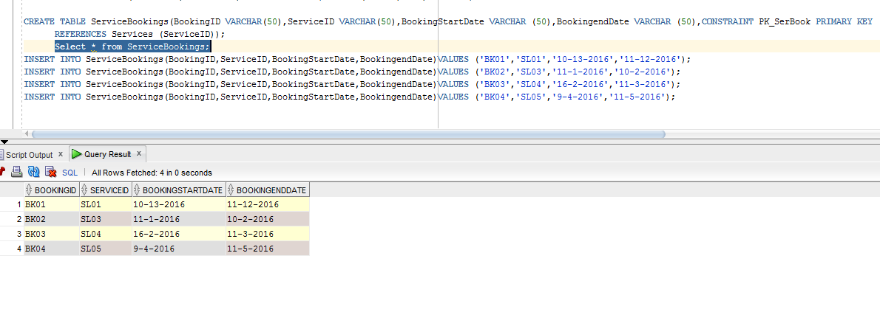

Payments

CREATE TABLE Payments(PaymentID VARCHAR(50),BookingID VARCHAR(50),PaymentAmount INTEGER, PaymentDate VARCHAR(50),CONSTRAINT PK_Payment PRIMARY KEY (PaymentID) ,CONSTRAINT fk_BookingID FOREIGN KEY (BookingID)

REFERENCES ServiceBookings (BookingID));

INSERT INTO Payments(PaymentID,BookingID,PaymentAmount,PaymentDate) VALUES ('P01','BK02',15000,'11-1-2016') ;

INSERT INTO Payments(PaymentID,BookingID,PaymentAmount,PaymentDate) VALUES ('P02','BK03',20000,'16-2-2016') ;

INSERT INTO Payments(PaymentID,BookingID,PaymentAmount,PaymentDate) VALUES ('P04','BK01',45000,'10-13-2016') ;

INSERT INTO Payments(PaymentID,BookingID,PaymentAmount,PaymentDate) VALUES ('P03','BK04',5000,'9-4-2016') ;

Select * from Payments;

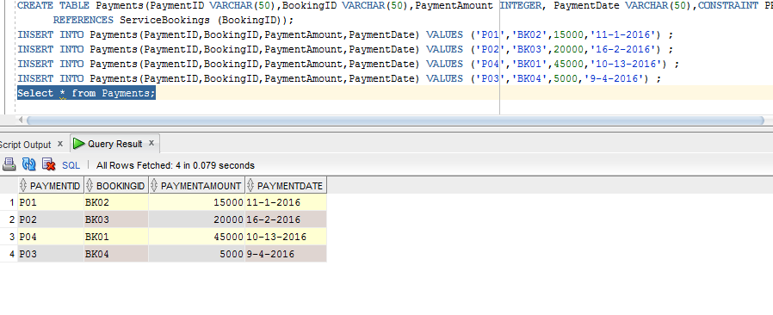

Bookings

CREATE TABLE Bookings(BookingFactID VARCHAR(50),travel_ID VARCHAR(50),StaffAID VARCHAR(50) , CustID VARCHAR(50),CalID VARCHAR(50),

OutComeCode VARCHAR(50),StatusCode VARCHAR(50),LevelCode VARCHAR(50),ServiceID VARCHAR(50),BookingID VARCHAR(50),PaymentID VARCHAR(50),

otherDetails VARCHAR(50), CONSTRAINT PK_BookingFactID PRIMARY KEY (BookingFactID),

CONSTRAINT fk_traveler_ID FOREIGN KEY (travel_ID)

REFERENCES Travel_Agency (travel_ID),

CONSTRAINT fk_StaffAsID FOREIGN KEY (StaffAID)

REFERENCES Staff_Agency (StaffAID),

CONSTRAINT fk_CustoID FOREIGN KEY (CustID)

REFERENCES Customers (CustID),

CONSTRAINT fk_CaleID FOREIGN KEY (CalID)

REFERENCES Calendar (CalID),

CONSTRAINT fk_OutComesCode FOREIGN KEY (OutComeCode)

REFERENCES BookingOutcomes (OutComeCode),

CONSTRAINT fk_StatussCode FOREIGN KEY (StatusCode)

REFERENCES BookingStatus (StatusCode),

CONSTRAINT fk_LevelsCode FOREIGN KEY (LevelCode)

REFERENCES BookingServiceLevel (LevelCode),

CONSTRAINT fk_ServicesID FOREIGN KEY (ServiceID)

REFERENCES Services (ServiceID),

CONSTRAINT fk_BookingsID FOREIGN KEY (BookingID)

REFERENCES ServiceBookings (BookingID),

CONSTRAINT fk_PaymenteID FOREIGN KEY (PaymentID)

REFERENCES Payments (PaymentID));

INSERT INTO Bookings(BookingFactID ,travel_ID ,StaffAID ,CustID ,CalID ,

OutComeCode ,StatusCode ,LevelCode ,ServiceID ,BookingID,PaymentID,otherDetails )VALUES

('BF01','TA45','ST76','CS45','CA11','O2','S4','L4','SL01','BK01','P02','any Concessions 10%');

INSERT INTO Bookings(BookingFactID ,travel_ID ,StaffAID ,CustID ,CalID ,

OutComeCode ,StatusCode ,LevelCode ,ServiceID ,BookingID,PaymentID,otherDetails )

VALUES('BF04','TA23','ST80','CS23','CA10','O3','S3','L1','SL03','BK02','P01','No Concessions');

INSERT INTO Bookings(BookingFactID ,travel_ID ,StaffAID ,CustID ,CalID ,

OutComeCode ,StatusCode ,LevelCode ,ServiceID ,BookingID,PaymentID,otherDetails )

VALUES('BF03','TA12','ST90','CS12','CA8','O4','S5','L5','SL04','BK03','P02','15% Concessions');

INSERT INTO Bookings(BookingFactID ,travel_ID ,StaffAID ,CustID ,CalID ,

OutComeCode ,StatusCode ,LevelCode ,ServiceID ,BookingID,PaymentID,otherDetails )

VALUES('BF02','TA10','ST92','CS10','CA9','O5','S2','L5','SL05','BK04','P03','2% Concessions');

select * from Bookings;

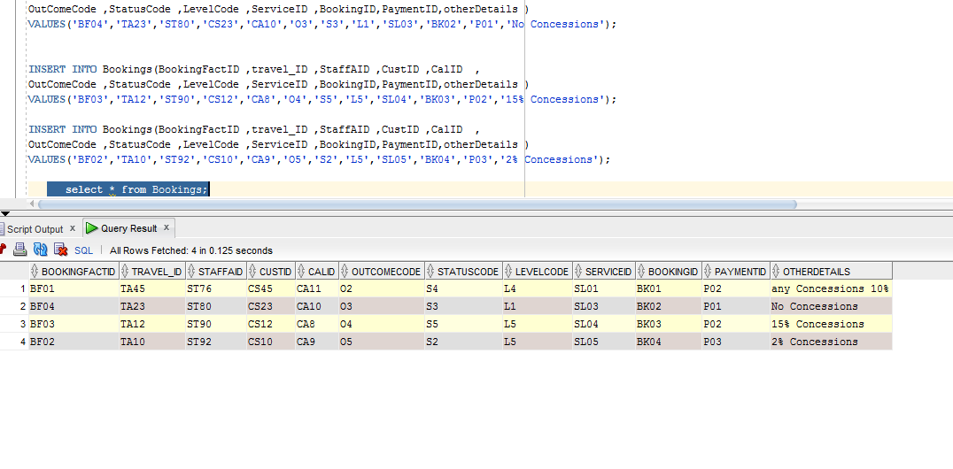

1.Find Staff who has StaffAID ST90 from staff

SELECT * FROM Staff_Agency WHERE StaffAId='ST90';

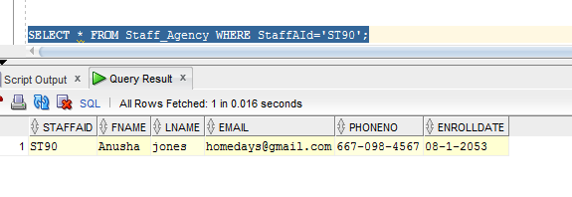

2.List the Payments details along with whose amount is below 10000

SELECT PaymentID,BookingID,PaymentAmount,PaymentDate FROM Payments

WHERE PaymentAmount < 10000;

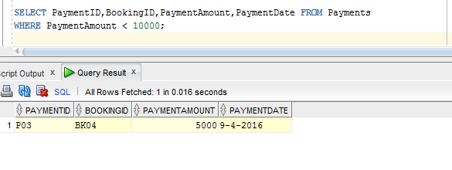

3.list the ServiceBookings who has BookingID as BK02 And ServiceID as SL03

SELECT * FROM ServiceBookings WHERE BookingID='BK02' AND ServiceID='SL03';

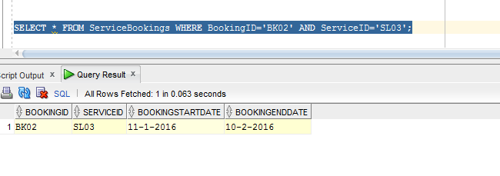

4. Order the Services by their ServiceID By descending order.

**SELECT * FROM Services ORDER BY ServiceID DESC;**

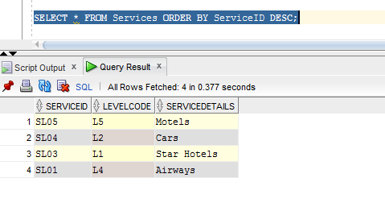

**5**. **Order BookingServiceLevel by their LevelCode By Ascending order**.

SELECT * FROM BookingServiceLevel ORDER BY LevelCode ASC;

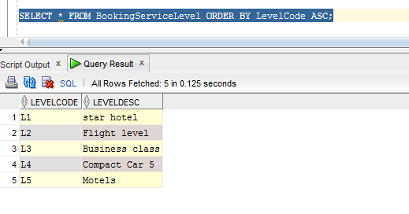

**B9 : Fifteen Queries in English sentences for the project.**

1. Retrieve all staff members from staff table

2. Update a particular staff member in staff table

3. Retrieve a particular Booking details based on BookingID

4. Retrieve a Level details based on LevelCode

5. Retrieve all Customers data from customers table

6. Retrieve all Booking status in Agency from Booking status Table

7.List the Payments details along with whose amount is below 10000

8. Order BookingServiceLevel by their LevelCode By Ascending order.

9. Order the Services by their ServiceID By descending order.

10. list the ServiceBookings who has BookingID as BK02 And ServiceID as SL03. from service bookings table

11. Insert a new customer details in customer table

12. Insert new service item in to service Table.

13. Find Staff who has StaffAID ST90 from staff table

14. Retrieve all the data from ServiceBookings Table

15. Retrieve all data from payments Table